You need to do the following steps:

1. Go to <https://app.cvat.ai/> and log in. If you don't have an account, create one.
2. After authorization, create a new task with the following parameters:
   * Name: Segmentation task
   * Labels:
     + Construction
     + Tree
     + Plant
     + Lawn
     + Solid surface
     + Water surface
     + Short barrier
     + Item
     + Sky
     + Earth
     + Undefined
   * Add images from the **"Images for annotation"** folder, which is in the same archive
3. Open the created task and annotate all images according to the rules described in the Task Requirements section below
4. Save the task and provide a link to the task in this form <https://forms.gle/fyGfyMyTBrd9wp8u7>

**Documentation**:

*Account registration*:

<https://opencv.github.io/cvat/docs/manual/basics/registration/>

*Task creation*:

<https://opencv.github.io/cvat/docs/manual/basics/create_an_annotation_task/>

*Brush tool*:

<https://opencv.github.io/cvat/docs/manual/advanced/annotation-with-brush-tool/>

*Layers*:

[CVAT.ai Product Tour #20: Improve Annotation Speed and Accuracy with Layers](https://www.youtube.com/watch?v=TCRTG5GHZzA)

*Remove underlying pixels:* <https://opencv.github.io/cvat/docs/manual/advanced/annotation-with-brush-tool/#remove-underlying-pixels>

## **Task requirements**

This task is to annotate objects in an image using the Brush tool.

Each object in the image must be segmented and labeled with a class from the list.

There should be no unannotated pixels in the image.

Masks should have minimal overlap (to minimise mask overlap use the "Remove underlying pixels" function) or they should be annotated using layers.

Objects behind the glass do not need to be annotated.

**Class list**:

* Construction
* Tree
* Plant
* Lawn
* Solid surface
* Undefined
* Short barrier
* Item
* Sky
* Water surface
* Earth

## **Class descriptions:**

### **Construction**

Any man-made structures.

Buildings (including everything on them), fences

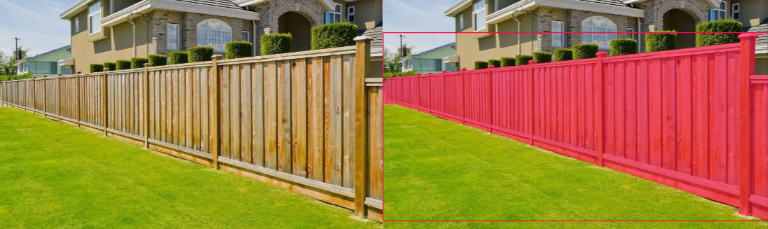

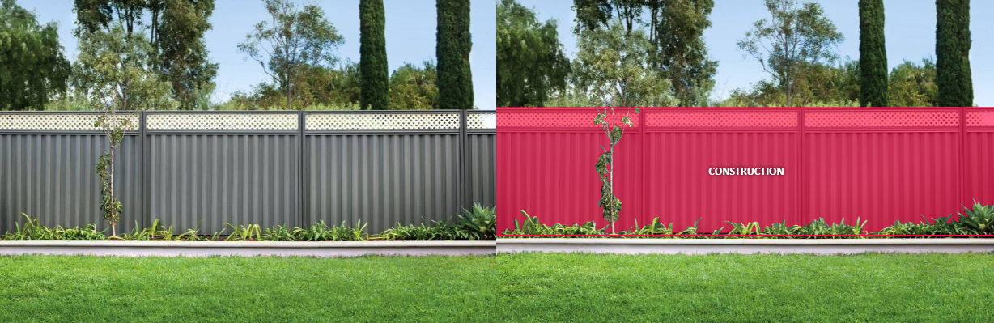

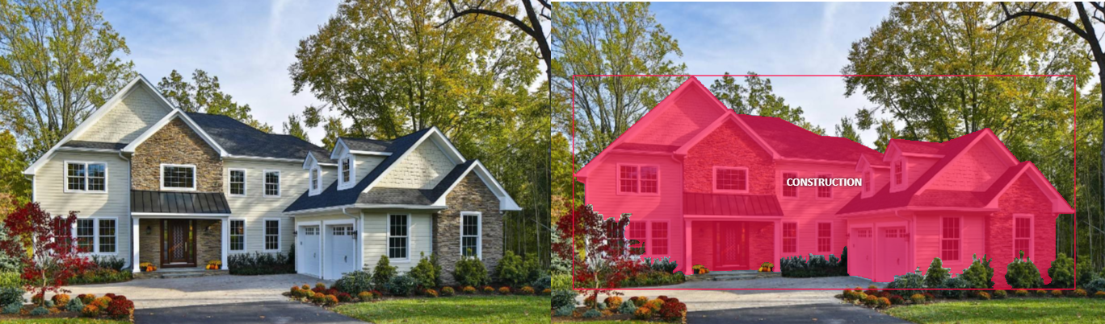

### **Tree**

The trunk and crown should be included in the mask. The tree mask should include the trunk and crown.

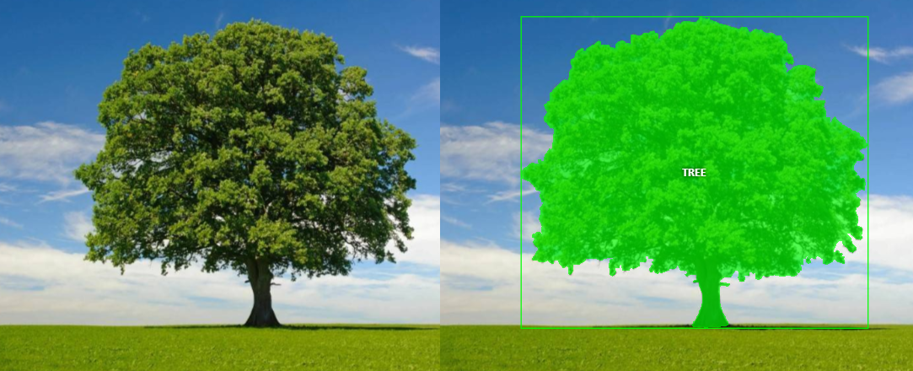

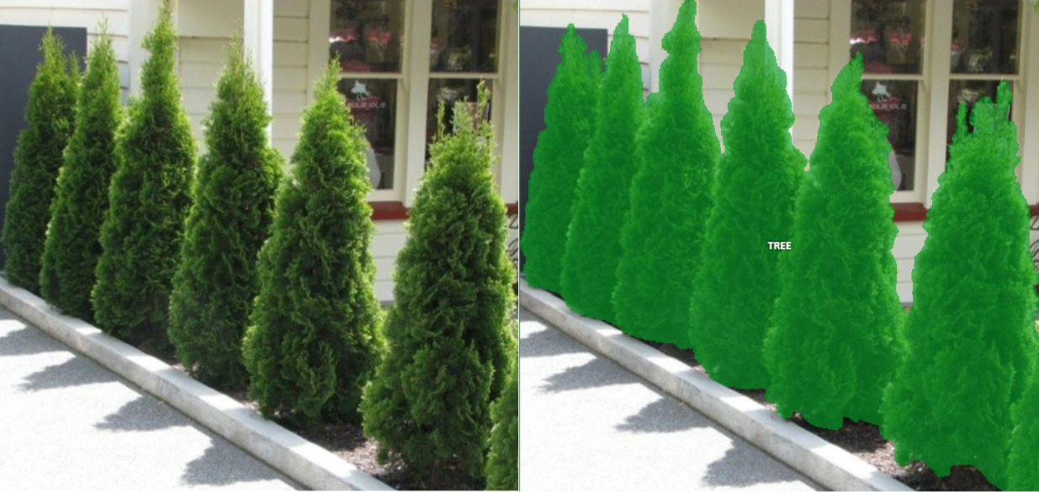

If the crowns of trees overlap each other and it's hard to define the boundary between them, you should annotate such trees with a single mask.

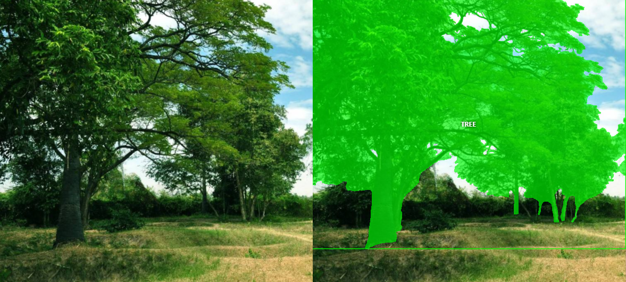

### **Plant**

Any plant except trees and lawns. And any potted plant.

If a group of plants overlaps each other and it’s hard to define the boundary between them, you should annotate such plants with a single mask.

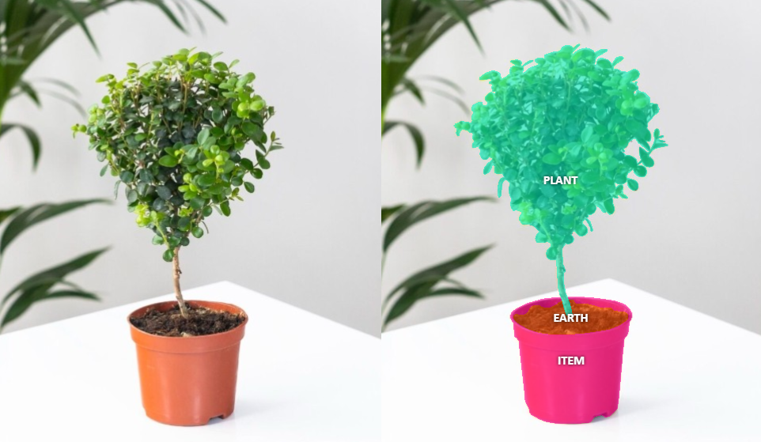

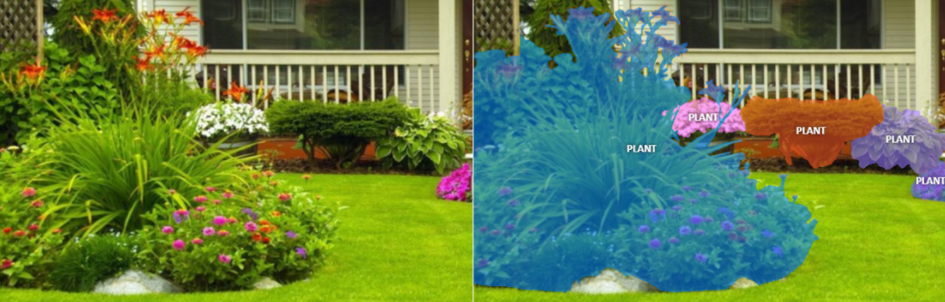

### **Lawn**

An area of short, regularly mown grass in the garden of a house or park.

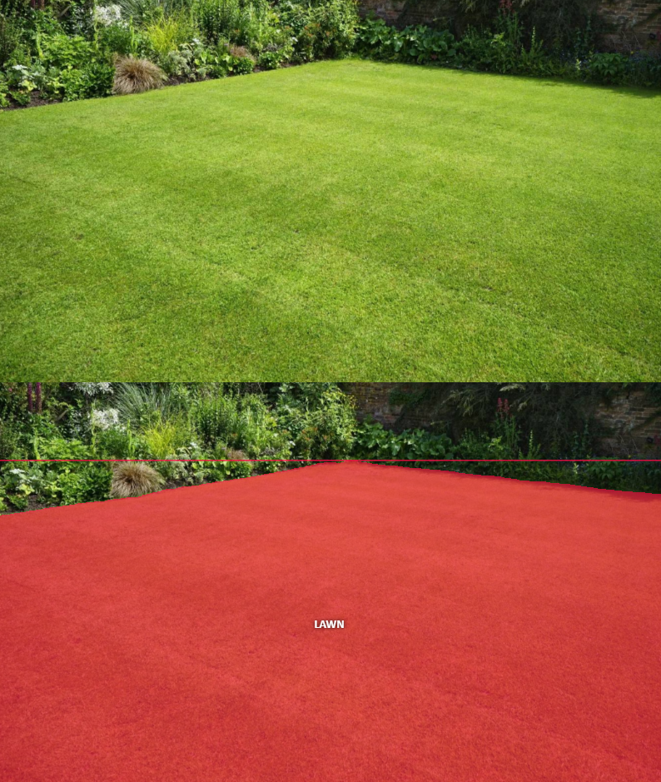

### 

### **Solid surface**

Man made horizontal flat material on the ground.

Road, asphalt, passable stone tiles, wooden deck, pavement.

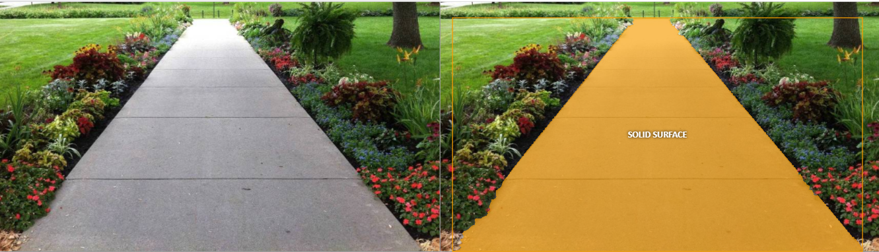

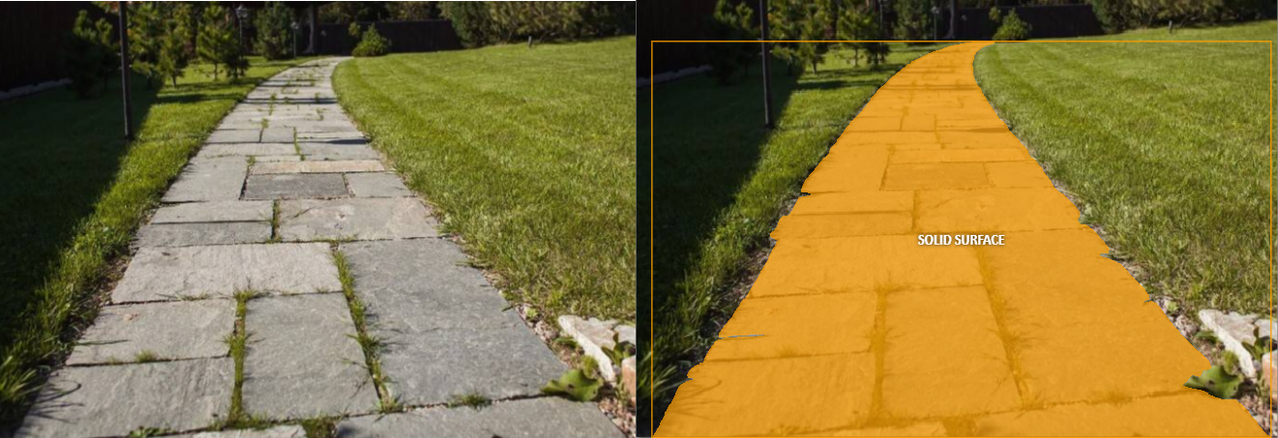

### **Short barrier**

Vertical surfaces or faces that serve as short barriers or boundaries. They are characterized by their upright orientation and shortness. They can appear in the edges of curbs, or borders of gardens.

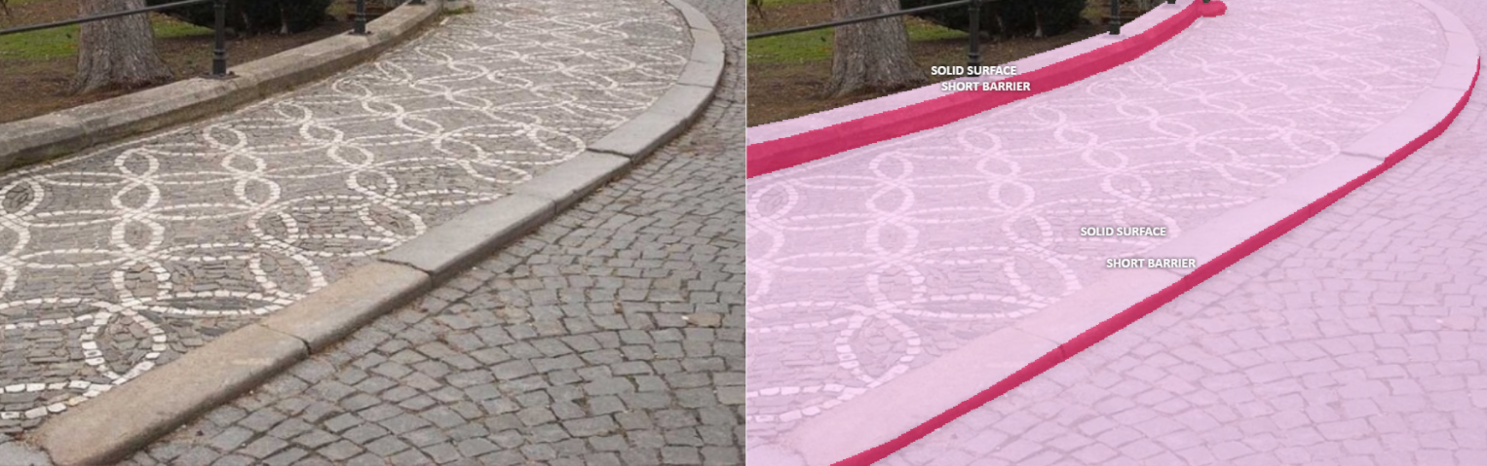

### 

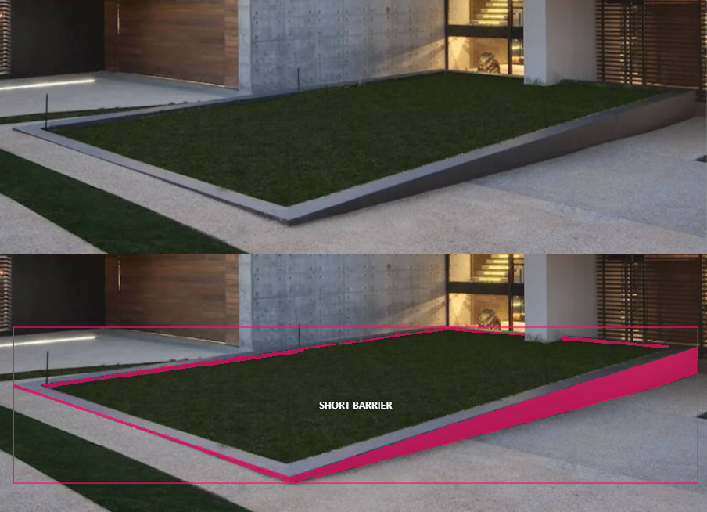

### **Item**

Any inanimate object including furniture and other things.

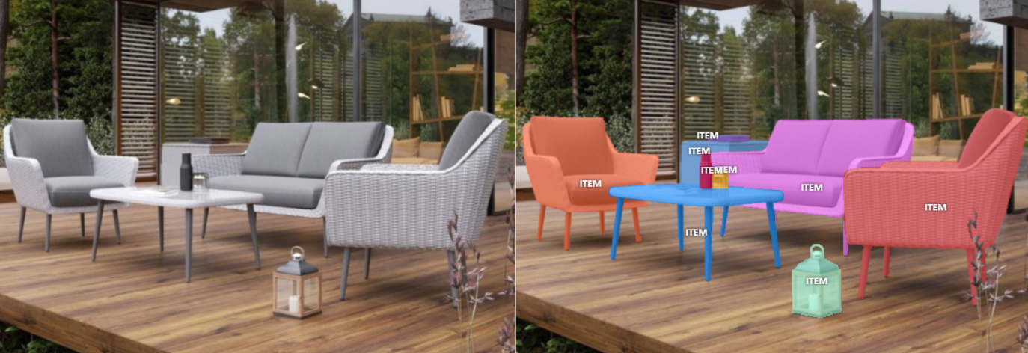

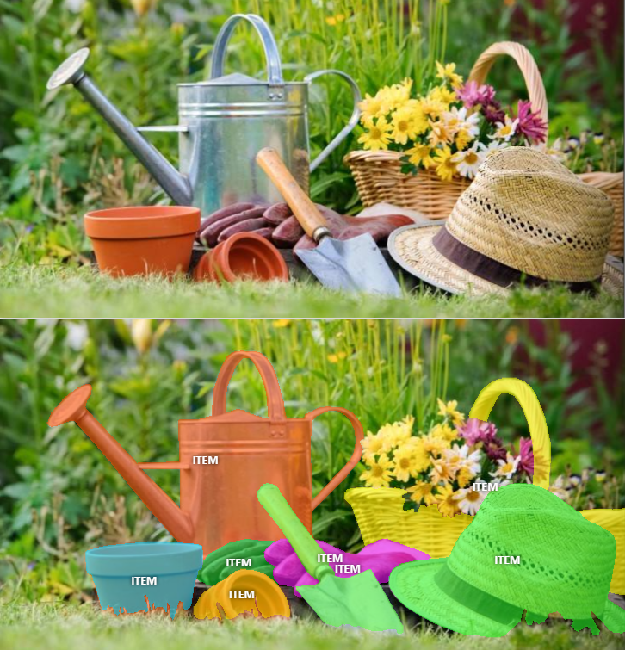

### **Sky**

Blue and bright background. Includes astral objects and clouds.

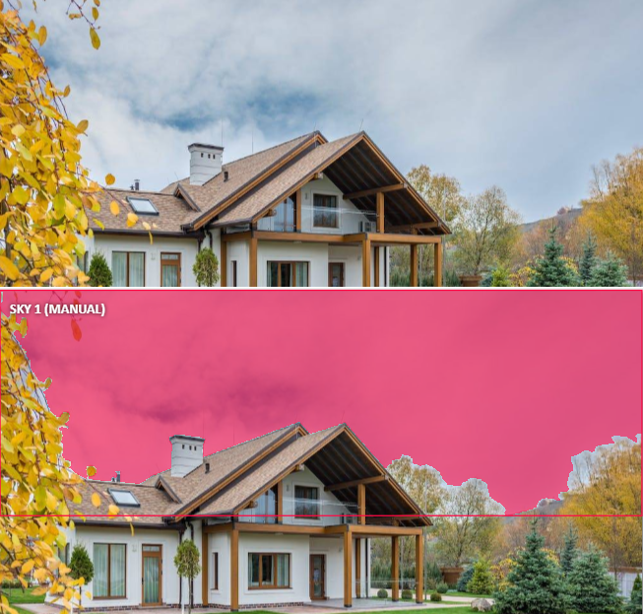

### 

### 

### **Water surface**

Any surface of water.

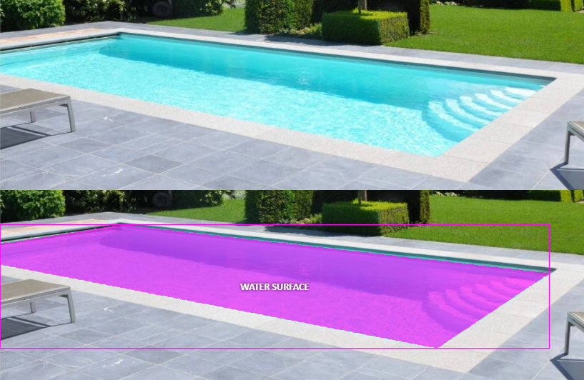

### **Earth**

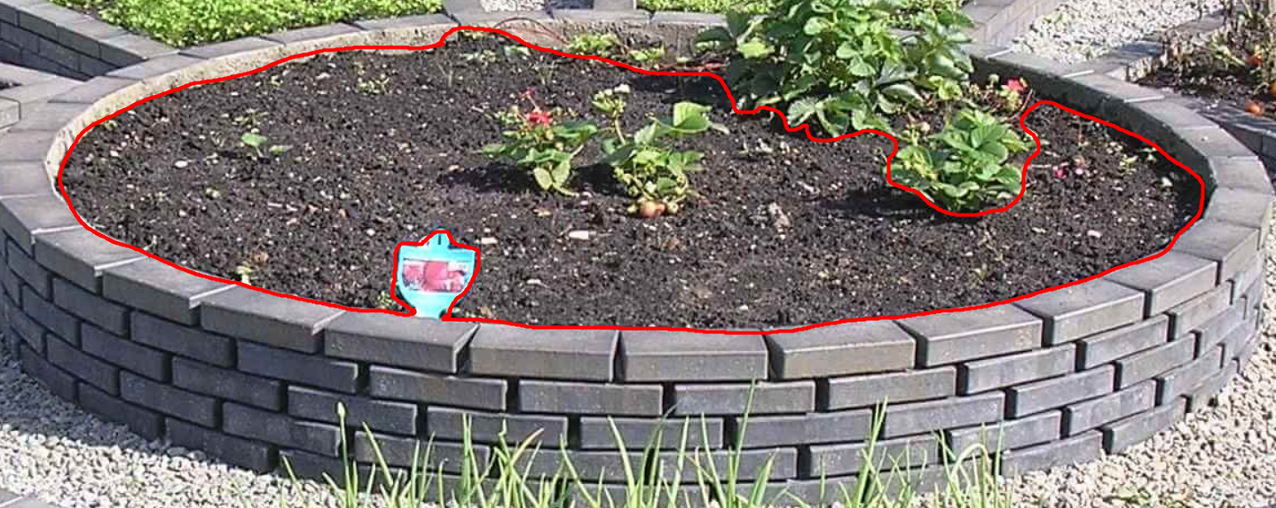

### **Undefined**

An area or object that cannot be recognized and assigned to a particular class.